Chapter test with answers
Chapter 6 Water and the intermolecular forces
Time permitted: 30 minutes
 | Section | Number of questions | Marks available
A | Multiple choice | 15 | 15
B | Short answer | 5 | 15
 | Total |  | 30
Scale:
A+ | 29–30 | A | 26–28 | B | 23–25 | C | 19–22 | D | 15–18 | E | 9–14 | UG | 0–8
Section A Multiple choice (15 marks)
Section A consists of 15 questions, each worth one mark. Each question has only one correct answer. Circle the correct answer. Attempt all questions. Marks will not be deducted for incorrect answers. You are advised to spend no more than 15 minutes on this section.
1 What shape are water molecules?
A Linear
B Trigonal planar
C Bent
D Tetrahedral
2 Which of the following processes does not involve ‘breaking’ or ‘forming’ intermolecular bonds?
A Ice melting
B Evaporating water from a salt solution
C Decomposing water into hydrogen and oxygen
D Water droplets condensing on a cold mirror

3 Which of the following is the correct valence structure diagram for chlorine gas?
A 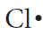
B 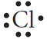
C 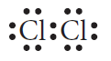
D 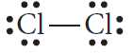
4 A molecule with a tetrahedral shape is identified as having:
A 4 electron pairs and 0 lone pairs on the central atom.
B 3 electron pairs and 1 lone pair on the central atom.
C 4 electron pairs and 1 lone pair on the central atom.
D 4 electron pairs and 2 lone pairs on the central atom.
5 What is the maximum number of covalent bonds that a nitrogen atom can form?
A 3
B 2
C 1
D 0
6 In which of the following substances are bonding electrons shared evenly?
A Hydrogen chloride
B Water
C Ammonia
D Fluorine gas
7 The following all possess polar bonds, but which is a polar molecule?
A C2H4
B CCl4
C NH3
D CO2
8 The intermolecular forces in order of increasing strength are:
A dipole–dipole < dispersion < hydrogen bonds.
B dipole–dipole > dispersion > hydrogen bonds.
C dispersion < dipole–dipole < hydrogen bonds.
D dispersion > dipole–dipole > hydrogen bonds.

9 When bonded with a hydrogen atom, which of the following atoms does not form a hydrogen bond?
A Nitrogen
B Chlorine
C Oxygen
D Fluorine
10 Which of the following has the lowest boiling point?
A HF
B H2S
C HCl
D CH4
11 Which type of force or bond exists between all covalent molecular substances?
A Dispersion forces
B Dipole–dipole forces
C Hydrogen bonds
D Covalent bonds
12 Capillary action helps plants take up soluble nutrients from the soil. Which of these forces is not involved in capillary action?
A Surface tension
B Cohesive force
C Adhesive force
D Gravitational force
13 Ionic compounds that are referred to as hydrated:
A are ionic salts that can be dissolved in water.
B have waters of crystallisation attached.
C have had waters of crystallisation removed by heating.
D all contain hydrogen bonds between the ions and the water molecules surrounding them.
14 Surfactants:
A decrease the wettability of a liquid.
B interrupt the surface tension of water.
C are hydrophobic.
D are hydrophilic.
15 The type of chromatography used to analyse the presence of drugs or the pigment in plants is:
A gas chromatography.
B high-performance liquid chromatography.
C thin-layer chromatography.
D paper chromatography.

Section B Short answer (15 marks)
Section B consists of five questions. Write your answers in the spaces provided. You are advised to spend 20 minutes on this section.
1 Describe the three types of intermolecular force. (3 marks)
Answer:
Dispersion forces: the weakest type of intermolecular force. These are the result of temporary dipoles that form due to the movement of electrons in the cloud surrounding atoms. The larger the atom or molecule, the greater the dispersion forces between molecules (since more electrons are present). (1 mark)
Dipole–dipole forces: occur between polar molecules. A permanent dipole can form in a bond when the electronegativity of the atoms in the bond is uneven. A net dipole occurs when the molecule is not symmetrical, leading to a slightly positive end and a slightly negative end. Dipole–dipole forces occur when the slightly negative end of one molecule is attracted to the slightly positive end of a neighbouring molecule. (1 mark)
Hydrogen bonds: special type of dipole–dipole force, when the molecule contains the very electronegative atoms nitrogen, oxygen or fluorine, attached to a hydrogen atom. The dipole created is much larger than other dipole–dipole forces, so the strength of the hydrogen bond is much greater (about of a covalent bond). (1 mark)
2 a Draw an electron dot diagram for the ammonia molecule. (1 mark)
Answer:
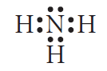
b Identify the shape of the ammonia molecule. Justify your answer.
(2 marks)
Answer: Ammonia is trigonal pyramidal. (1 mark)
NH3, as shown above, has four electron pairs, including three bonding pairs and one lone pair. The four pairs of electrons repel one another until they are as far apart as possible. With three bonding and one lone pair of electrons, the shape formed is pyramidal, with the hydrogen atoms at the three base corners of a tetrahedron. (1 mark)

3 Below is a graph showing the boiling points of hydrides of groups 14–17. Discuss the shape of the graphs for the boiling points in group 14 and group 16.
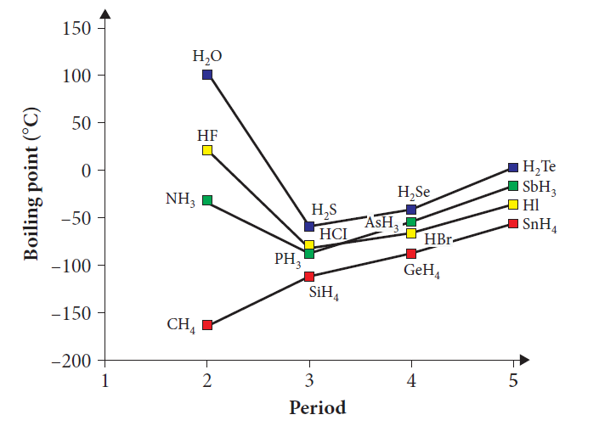(3 marks)
Answer: Hydrides in Group 14 of the Periodic Table are all non-polar molecules. Thus they only have dispersion forces between their molecules. This is the weakest type of intermolecular force and not much energy is required to separate the molecules from each other, so their boiling points are lower than those of Group 16. The boiling points for the substances in Group 14 also increase almost linearly because, as the molecular weight increases, they have greater dispersion forces between their molecules.
The boiling points of the hydrides of Group 16 are higher than those of Group 14 because they have stronger dipole–dipole forces between their molecules. This is because the molecules are all polar. They also have higher molecular weights than Group 14. However, ammonia does not follow the trend of its group because it has hydrogen bonds, which are even stronger, between molecules. Thus, more energy is required to separate the molecules from one another, so the boiling point is higher.

4 Use a labelled diagram to describe why ethanol is so useful as a solvent.
(3 marks)
Answer:
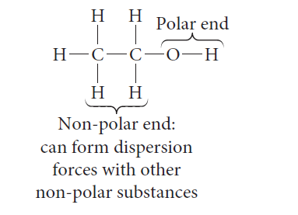
Ethanol has both a polar and a non-polar end. As like dissolves like, this means the polar end can attract other polar (and ionic) substances, dissolving them. The non-polar end can attract non-polar substances, dissolving them.
5 Use a table to contrast gas chromatography and high-performance liquid chromatography. (3 marks)
Answer:
 | Gas chromatography | High-performance liquid chromatography
Stationary phase | Fine, long column | Short column
Mobile phase | Inert gas | Liquid such as a water–methanol mix
Uses/to detect | Small heat stable organic compounds such as ethanol | Larger organic compounds
Method/equipment | Sample injected into oven; gas does not play an important role in adsorption/desorption | Uses a pump to push liquid through the denser packed column; liquid plays an important role in adsorption/desorption

End of test (30 marks)

